**Instructional Activity Resources for 5M-NSCE 1**

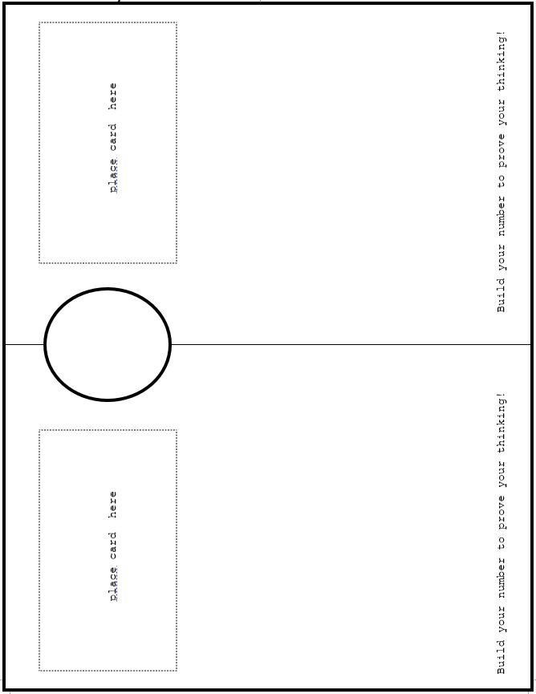

number lines :
0 to 10, 10 to 20, 20 to 30, 30 to 40, 40 to 50, 50 to 60, 60 to 70, 70 to 80, 80 to 90, 90 to 100.

**Instructional Activity Resources for 5M -NSCE 4**

printable cards with:
Fractions: 1/2, 1/4, 1/8;
A rectangle with 1/2 shaded;
A circle with 1/2 shaded;
Two circles and one is shaded;
A rectangle with 1/4 shaded;
Four circles and one is shaded;
A circle with 1/4 shaded;
A circle with 1/8 shaded;
Eight circles and one is shaded;
A rectangle with 1/8 shaded.