Reporting Category | Standard | Essential Skills and Knowledge | Related Basic Skill or Concept | Sample Instructional Activities
Number, Number Sense, Computation and Estimation | 3M-NSCE 1 | - Identify and write numbers 0 to 30.  - Identify the place value of tens on a number line between 0 to 30. | - One-to-one correspondence  - Counting  - Building the value of number with units and rods | - Lay out number cards 0-30 and have students select a number and say the number aloud.  - Roll 2 dot cubes, have the student write a 2-digit number based on what they rolled; have students make the larger number and the smaller number based on the two numbers rolled (e.g.; 42 and 24).  - Give student a picture of units and rods. Have them determine the amount and match it to the appropriate number card.
Number, Number Sense, Computation and Estimation | 3M-NSCE 2 | - Solve addition and subtraction problems when result is unknown with numbers 0-30. | - Understand ways to make groups of 10  - Meaning of + and - symbols | - Have a deck of cards numbered 0-30. Turn over two cards. Have a student roll a die that has + and - signs. The student then adds or subtracts the two numbers and writes the sum or difference.  - Give student an addition or subtraction fact. Give them a problem solving mat and some counters so they can act out the problem using the counters. Have them say or write the total in numbers.  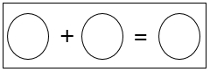
Number, Number Sense, Computation and Estimation | 3M-NSCE 3 | - Determine fractional part from a whole.  - Recognize that shapes can be portioned into equal areas. | - Recognize shapes that are cut into equal and/or unequal parts | - Give student several cards that are cut into equal parts (ex: halves, thirds, fourths, etc.). Have the student select all the cards that show halves.  - Give student different shapes (ex: squares, triangles, circles, etc.) Have the student divide the shape into equal parts. For example, have the student split a rectangle into 3 equal parts.
Number, Number Sense, Computation and Estimation | 3M -NSCE 4 | - Add to solve single-step story problems from 0-30.  - Identify place value to tens place. | - Understand ways to make 10  - Understand meaning of + and - | - Use the Make Ten strategy (e.g.; 9 + 5 is make the 9 a 10 and make the 5 a 4 and 10 + 4 = 14 so 9 + 5 also = 14).  - Use the Hundreds Board to model counts of 10 to 100 and have students note that for each count of 10, the number in the 10’s place increases by 1-ten-10, 20, 30, 40,…100.
Number, Number Sense, Computation and Estimation | 3M -NSCE 5 | - Use addition to find total number of objects arranged within equal groups up to a total of 10.  - Count by tens using money. | - Skip count by 2s, 5s, and 10s | - Give students a piece of paper that has pre-drawn circles. Ask them to put a certain amount in each circle. Have them find the total and write a number sentence to show how they found the total. For example, you may give them 3 circles and ask them to place 3 counters in each circle. They would find the total and write 3+3+3=9.  - Give students a collection of dimes. Have them count by 10s to find total.
Number, Number Sense, Computation and Estimation | 3M -NSCE 6 | - Use repeated addition and equal groups to find the total number of objects to find the sum. | - Skip count by 2s, 5,s and 10s | - Give students a piece of paper that has pre-drawn circles. Ask them to put a certain amount in each circle. Have them find the total and write a number sentence to show how they found the total. For example, you may give them 4 circles and ask them to place 2 counters in each circle. They would find the total and write 2+2+2+2=8.  - Give students a piece of paper that has pre-drawn circles. Ask them to put a certain amount in each circle. Have them find the total and write a number sentence to show how they found the total. For example, you may give them 2 circles and ask them to place 5 counters in each circle. They would find the total and write 5+5=10.
Number, Number Sense, Computation and Estimation | 3M -NSCE 7 | - Differentiate between whole, half, and fourth. | - Understanding that shapes can be divided into equal parts | - Use a square to represent the whole then fold it in half to represent one-half then fold again to represent one-fourth.  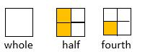  This activity can also be done with other shapes that are easy to fold into halves and fourths.
Measurement and Geometry | 3M-MG 1 | - Identify coins (penny, nickel, dime, quarter) and their values. | - Understand that the size of the coin does not reflect the value of the coin | 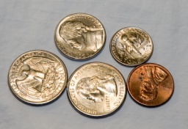  - Although the penny is larger than a dime and smaller than a nickel, its’ value is 1 cent and the nickel and dime are valued at 5 and 10 cents, respectively.
Measurement and Geometry | 3M-MG 2 | - Identify standard units of measure for mass and liquid.  - Measure length of objects using standard tools, such as rulers, yardsticks, and meter sticks. | - Understand that things can be measured using various tools  - Identify tools used to measure capacity, mass/weight, and length | - Have students measure mass using the units of ounces, pounds, grams, and kilograms and tools such as scales, measuring cups, etc.
Measurement and Geometry | 3M-MG 3 | - Tell time to the hour on a digital clock. | - Recognize and read numbers | - Have students read the numerals below to assist with telling time.  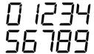
Measurement and Geometry | 3M-MG 4 | - Identify models and pictures of plane geometric figures (circle, square, rectangle, and triangle) and solid geometric figures (cube, rectangular prism, square pyramid, sphere, cone, and cylinder) by name.  - Identify and describe plane geometric figures by counting the number of sides and angles.  - Identify and describe solid geometric figures by counting the number of angles, vertices, edges, and by the number and shape of faces. | - Identify figures  - Describe figures  - Understand similarities and differences between figures | - Having students choose two triangles out of a group of 5 figures.  - Have students trace the shapes of geometric solids and name the shapes of faces they traced.  - Sort real world items by their solid geometric shapes (e.g., a basketball, a baseball, and a tennis ball would all be sorted under a picture of a sphere).
Probability, Statistics, Patterns, Functions, and Algebra | 3M-PSPFA 1 | - Create picture graphs from collected data  - Use picture or bar graph data to answer questions  - Insert data into a preconstructed bar graph template  - Interpret data from a variety of graphs to answer questions | - Recognize bar graphs and pictographs  - Use collected data in graphs | - Students identify bar and pictographs from several graphing formats (e.g.; 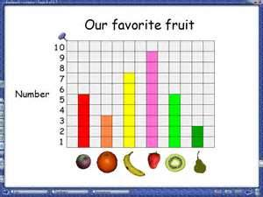  (bar graph)  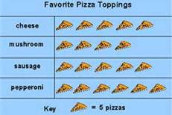  (picture graph)  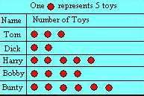  (pictograph)
Probability, Statistics, Patterns, Functions, and Algebra | 3M-PSPFA 2 | - Identify arithmetic patterns | - Understand that patterns can repeat and grow | - Have students extend patterns that both repeat and grow (e.g.; 1, 3, 5, 1, 3, 5, 1, 3, 5,..; 1, 2, 4, 7, 11, 16, …)
Probability, Statistics, Patterns, Functions, and Algebra | 3M-PSPFA 3 | - Demonstrate the connection between repeated addition and multiplication | - Understand that multiplication can be represented as repeated addition | - Have students  model 3+3+3 ∙∙∙ + ∙∙∙ +∙∙∙  then model 3X3  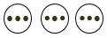  - Have students discuss that three groups (or sets) of three is 9. Next, have students discuss that 3X3 is three groups (or sets) of three and that is 9. They should recognize the two  models/number sentences are equal, so 3+3+3=3x3.

