**Instructional Activity Resources for 8M-NSCE 1**

There are cards in 4 rows of 2:
Row 1: The left card has a picture of a 3 dimensional 100 block model, with  2 three dimensional 10 block models, and 3 three dimensional 1 block models. The right card there is a picture of a 3D 100 block model, 4 3D 10 block models and 4 3D block models. 
Row 2: The left card has 2 3D 100 block models, 3 3D 10 block models, and 9 3D one block models. The right card has a picture of 2 3D 100 block models, 4 3D 10 block models, and 1 3D single block model. 
Row 3: The left card has a picture of 1 3D 100 block model, 1 3D 10 block model. and 3 3D single block models. The card to the right has a picture of 7 3D 10 block models and 1 3D single block model. 
Row 4: The left card has 2 3D 100 block models, and 4 3D 10 block models. The right card has a picture of 3 3D 100 block models and 7 3D single block models.



There are cards in 4 rows of 2. 
Row 1: left card: 123. Right card: 154
Row 2: left card: 239. Right card: 241
Row 3: left card: 113. Right card: 71
Row 4: left card: 240. Right card: 307


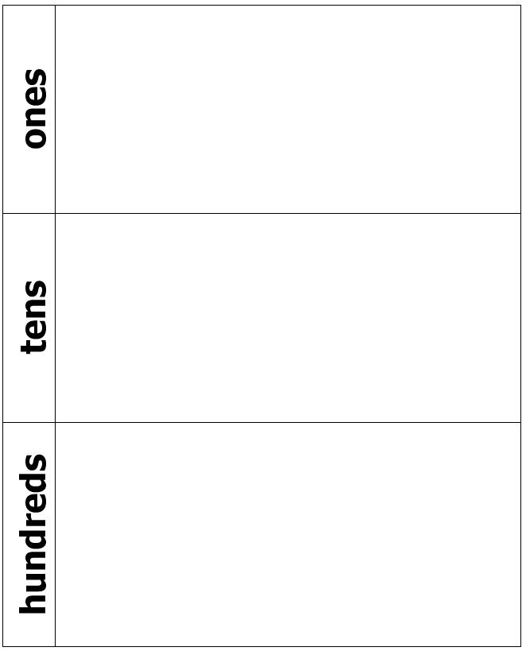

There are cards that are in  3 rows of 4. 
Row 1: 0, 1, 2, 3
Row 2: 4, 5, 6, 7
Row 3: 8, 9, +, +


**Compose and Decompose Numbers**

There are 7 cards with numbers displayed on them. 
Top card: 726
Underneath 726 numbers are displayed in 3 rows of 2
Row 1: 700 and 500
Row 2: 20 and 40
Row 3: 6 and 8 


There are numbers displayed in cards. The top card: 465
Underneath the top card numbers are displayed in 3 rows of 2. 
Row 1: 400 and 600
Row 2: 70 and 60 
Row 3: 5 and 4

There are 7 cards with numbers displayed on them. 
The top card: 152
Underneath the top card numbers are displayed in cards as 3 rows of 2
Row 1: 200, 100
Row 2: 30, 50
Row 3: 2, 1

There are 7 cards that display numbers. 
Top card: 897
Underneath the top card numbers displayed in 3 rows of 2. 
Row 1: 800 and 900
Row 2: 90 and 10
Row 3: 7 and 3


**Instructional Activity Resources for 8M-NSCE 2**

**Subtraction With Like Denominators with Shaded Pieces**

two over 2 minus 1-half
Modeled by using a rectangle that is fully shaded minus a rectangle that is half shaded. Display the answer by shading the correct amount of peices in the blank rectangle below. 

three-fourths minus 1-fourth
Modeled by a rectangle divided into 4 pieces and 3 of the pieces are shaded minus a rectangle divided into 4 pieces and 1 piece is shaded. 
Display the answer by shading in the correct amount of pieces in the rectangle below. 

**Subtraction With Like Denominators**

five eighths minus 2-eighths 
modeled by a rectangle that is divided into 8 piecesand 5 of those pieces are shaded in minus a rectangle also divided into 8 pieces with 2 of the 8 pieces are shaded in. Display the answer by shading in the correct amount of pieces in the blank rectangle. 

three-thirds minus one-third
Modeled by using a rectangle that is divided into 3 pieces. Three of the three pieces are shaded in minus a rectangle with only one of the 3 pieces shaded in. Display the answer by shading the correct amount of pieces in the blank rectangle. 

**Subtraction With Like Denominators without Shaded Pieces**

Calculate two over two minus one-half
Modeled by a rectangle divided into two pieces minus another rectangle divided into 2 pieces. 

three fouths minus one-fourth:
the first rectangle has 4 pieces in total minus the second rectangle that has 4 pieces in total.
display the result in bottom rectangle with total of 4 pieces by shading the right amount of pieces. 

**Subtraction With Like Denominators**

 five eighths minus two eighths:
the first rectangle has 8 pieces in total minus the second rectangle.
display the result in bottom rectangle with total of 8 pieces by shading the correct amount of pieces. 

three-thirds minus one-third
Modeled by a rectangle divided into 3 pices minus a rectangle divided into 3 pieces. Shade in the correct amount of pieces in the rectangles. 

**Instructional Activity Resources for 8M-NSCE 3**

There are 12 cards in 4 rows of 3. 
Row 1: left card: 5 hundredths as a decimal, middle card: five hundredths as a fraction, rigth card: 100 square model with 5 sqaures shaded in. 
Row 2: left card: ten hundreths as a decimal 0.10, middle card: ten hundredths as a fraction, right card: 100 sqaure model with 10 sqaures shaded in. 
Row 3: left card: 15 hundreths as a decimal, middle card: 15 hundreths as a fraction, rigth card: 100 sqaure model with 15 sqaures shaded in. 
Row 4: 20 hundreths as a decimal, middle card: 20 hundreths as a fraction, right card: 100 sqaure model with 20 sqaures shaded in. 


There are 12 cards in 4 rows of 3. 
Row 1: left card 25 hundredths as a decimal, middle card: 25 hundreths as a fraction, right card: 100 sqaure model with 25 sqaures shaded in. 
Row 2: 30 hundredths as a decimal, middle card: 30 hundreths as a fraction, right card: a 100 sqaure model with 30 sqaures shaded in. 
Row 3: left card: 35 hundredths as a decimal, middle card: 35 hundredths as a fraction, right card: a 100 sqaure model with 35 squares shaded in. 
Row 4: left card: 40 hundredths as a decimal, middle card: 40 hundredths as a fraction, right card: a 100 sqaure model with 40 squares shaded in. 

There are 12 cards in 4 rows of 3. 
Row 1: Left card: 45 hundredths as a decimal, middle card: 45 hundredths as a fraction, right card: a 100 sqaure model with 45 squares shaded in. 
Row 2: left card: 50 hundredths as a decimal. middle card: 50 hundredths as a fraction, right card: a 100 sqaure model with 50 sqaures shaded in. 
Row 3: left card: 55 hundredths as a decimal, middle card: 55 hundredths as a fraction, right card: a 100 sqaure model and 55 sqaures are shaded in. 
Row 4: left card: 60 hundredths as a decimal, middle card: 60 hundredths as a fraction, right card: a 100 square model and 60 sqaures are shaded in. 

There are 12 cards in 4 rows of 3
Row 1: Left card: 65 hundredths as a decimal, middle card: 35 hundredths as a fraction, right card: a 100 sqaure model and 65 squares are shaded in. 
Row 2: Left card: 70 hundredths as a decimal. middle card: 70 hundredths as a fraction, right card: a 100 square model with 70 sqaures shaded in. 
Row 3: left card: 75 hundredths as a decimal, middle card: 75 hundredths as a fraction, right card: a 100 square model and 75 sqaures are shaded in. 
Row 4: left card: 80 hundredths as a decimal, middle card: 80 hundredths as a fraction, right card: a 100 sqaure model with 80 squares shaded in. 

There are 12 cards in 3 rows of 3. 
Row 1: left card: 85 hundredths as a decimal middle card: 85 hundredths as a fraction, right card: a 100 sqaure model and 85 sqauares are shaded in. 
Row 2: left card: 90 hundredths as a decimal, middle card: 90 hundredths as a fraction, right card: a 100 square model and 90 squares are shaded in. 
Row 3: left card: 95 hundredths as a decimal, middle card: 95 hundredths as a fraction, right card: a 100 square model with 95 sqaures shaded in.

**100's Grid**

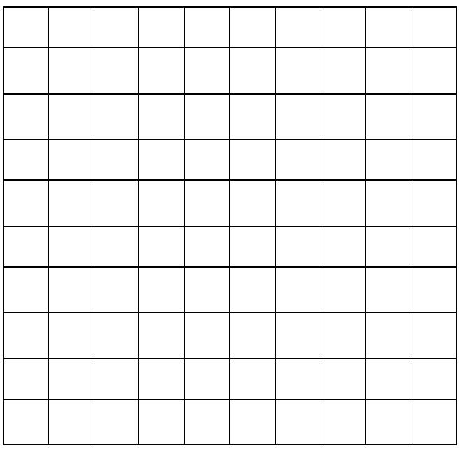

**Instructional Activity Resources for 8M-MG 1**

8 cards with angles displayed on them. They are in 4 rows of 2
Row 1: left card: an angle less than 90 degrees. Right card: a right angle of 90 degrees.
Row 2: left card: an angle less than 90 degrees. right card: an angle more than 90 degrees. 
Row 3: left card: an angle less than 90 degrees, right card: an angle more than 90 degrees. 
Row 4: left card: a right angle equal to 90 degrees. right card: a right angle equal to 90 degrees 

8 cards that display different angles. the cards are in 4 rows of 2
Row 1: left card: an angle greater than 90 degrees. Right card: an angle less than 90 degrees. 
Row 2: left card: an angle more than 90 degrees. Right card: a right angle equal to 90 degrees. 
row 3: left card: a right angle equal to 90 degrees. right card: an angle more tha 90 degrees. 
row 4:left card: an angle less than 90 degrees. right card: an angle less than 90 degrees 

**Building Angles**

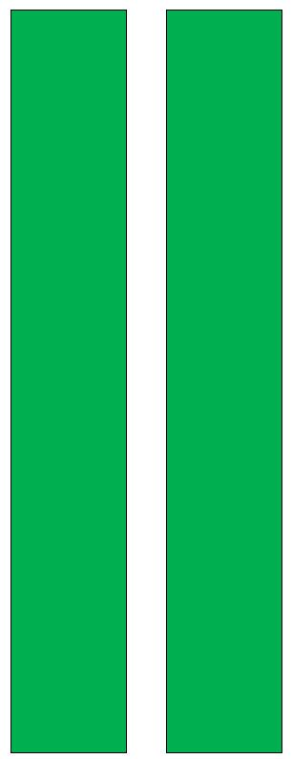

**Directions:**

**Connect angle legs with a brad.**

**Have students build right angles,**

**less than right angles, and greater than right angles using their angle maker.**

**Instructional Activity Resources for 8M-MG 2**

**Measurement Sort**

**Directions: Sort the following items with the best unit of measurement.**

top 4 cards: 
Top left card: displays the word cup
Top right: displays the word pint
Bottom left: displays the word quart
Bottom right: displays the word gallon. 
bottom 4 cards: 
Top left: a picture of a can of cola
top right: a picture of a bath tub
bottom left: a picture of a juice box
bottom right: a picture of a fish in a fish bowl 


there are 6 cards: 
Top left: a picture of 3 people playing in a pool. 
Top right: a picture of a yogurt container
middle left: a picture of a pot of water
middle right: a picture of a bottle of water 
bottom left: a picture of a cup of coffee. 
bottom right: a picture of a glue bottle 

6 cards with pictures of objects displayed on the. 
Top left: a picture of a watering can
top right: a picture of a bowl of soup 
middle left: a picture of a pot of coffee
middle right: a picture of a baby bottle 
bottom left: a picture of a truck 
bottom right: a picture of can of gasoline 

**Instructional Activity Resources for 8M-MG 3**

**Congruent Sets**

**Directions: Find congruent shapes. Use tracing paper to find congruent shapes.**

**Color each congruent set a different color.**

A set of congruent shapes: 
Towards the top: triangle, parrallelogram, trapazoid. 
towards the middle: trapazoid, rectangle, rectangle 
toward the bottom: oval, diamond, triangle 


**Congruency Cards**

there are 6 cards with shapes displayed on them. 
Top left: a hexagon
Top right: a triangle 
middle left: a rectangle 
middle right: an oval 
Bottom left: oval 
bottom right: a triangle 


There are 6 cards with shapes displayed on them. 
Top left: triangle
top right: triangle
middle left: rectangle
middle right: hexagon
bottom left: heart
bottom right: heart 

**Instructional Activity Resources for 8M-PSPFA 2**

There are cards in 8 rows of 2.
Row 1: left card: 5 more than a number. right card: 53 + t
Row 2: left card: A number minus 35. right card: d - 30
Row 3: left card: the sum of 57 and a number. right card: 5 + P
Row 4: left card: a number decreased by 45. right card: g-20 
row 5: left card: a number minus 20. right card: f-3
row 6: left card thirty less than a number. right card: r-45
row 7: left card: 3 less than a number. right card: y-35
row 8: left card: the sum of 35 and a number. right card 57+t

**Instructional Activity Resources for 8M-PSPFA 4**

**Build the Next Stage**

Directions: Using tiles, build what the next stage in each pattern would look like.

Stage 1: has a picture of one block.
stage 2: has a picture of 3 blocks
stange 3: has a picture of 6 blocks. 
stage 4: has a picture of 10 blocks
Stage 5: is unknown. How many blocks would be next? 

Stage 1: there is a picture of 1 block
Stage 2: there is a picture of 2 blocks. 
Stage 3: there is a picture of 3 blocks
Stage 4: there is a picture of 4 blocks
Stage 5: is unknown. How many blocks would be next?   
stage 1: there is a picture of 1 block
stage 2: there is a picture of 3 blocks
stage 3: there is a picture of 5 blocks
stage 4: there is a picture of 7 blocks
stage 5: how many blocks would be next. 


**Function Tables**

Table 1: 
Top row: 4, 5, 7, 9, 1
Bottom row: 8, 10, 14, 18, ? 

Table 2: 
Top row: 1, 2, 3, 4 , t
bottom row: 2, 4, 6, 8, ? 

Table 3: 
top row: 10, 20, 30, k, 50
bottom row: 20, 30, 40, ?, 60 

table 4: 
top row: 2, 3, 4, 5, m
bottom row: 5, 6, 7, 8, ? 